# Title: On any page of the website. A yellow “phone” icon of the call widget is half-cut.

**Priority:** High

**Severity:** S4 Minor

**Environment:**Google Pixel 7 Pro (3120×1440, Android 11 OS). Tested via Android Studio.

**Steps to reproduce**

1. Open the Main page: [https://zpolis.com.ua](https://zpolis.com.ua/)

2. Look at the yellow “phone” icon on the left side of the screen.

**Actual result**

We see that a half of the yellow phone icon image is cut

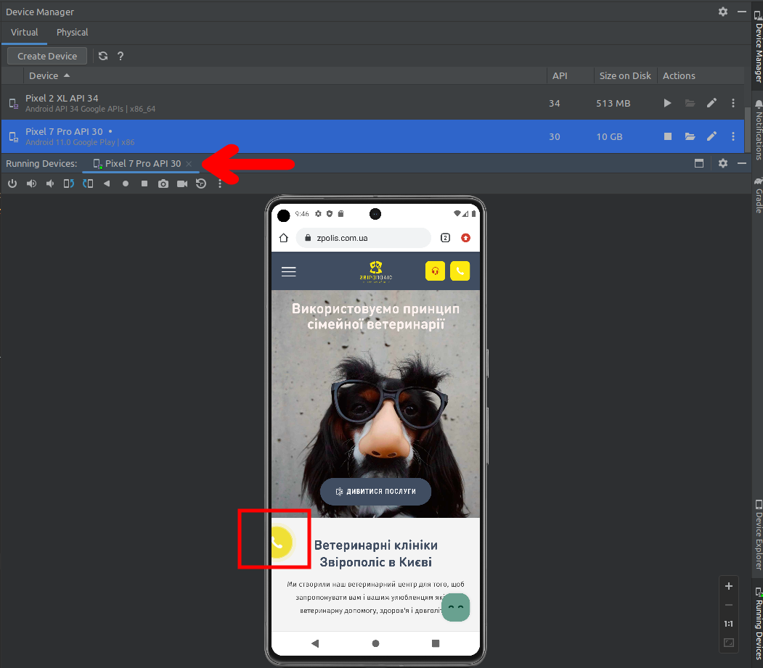

**Expected result**

The icon image must be totally visible.

*Screenshot from* ***Jira****:*

